You are given a **tree** (i.e. a connected, undirected graph that has no cycles) **rooted** at node 0 consisting of n nodes numbered from 0 to n - 1. The tree is represented by a **0-indexed** array parent of size n, where parent[i] is the parent of node i. Since node 0 is the root, parent[0] == -1.

You are also given a string s of length n, where s[i] is the character assigned to the edge between i and parent[i]. s[0] can be ignored.

Return *the number of pairs of nodes* (u, v) *such that* u < v *and the characters assigned to edges on the path from* u *to* v *can be* ***rearranged*** *to form a* ***palindrome***.

A string is a **palindrome** when it reads the same backwards as forwards.

**Example 1:**

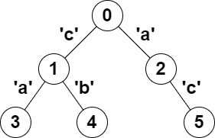

Input: parent = [-1,0,0,1,1,2], s = "acaabc"  
Output: 8  
Explanation: The valid pairs are:  
- All the pairs (0,1), (0,2), (1,3), (1,4) and (2,5) result in one character which is always a palindrome.  
- The pair (2,3) result in the string "aca" which is a palindrome.  
- The pair (1,5) result in the string "cac" which is a palindrome.  
- The pair (3,5) result in the string "acac" which can be rearranged into the palindrome "acca".

**Example 2:**

Input: parent = [-1,0,0,0,0], s = "aaaaa"  
Output: 10  
Explanation: Any pair of nodes (u,v) where u < v is valid.

**Constraints:**

* n == parent.length == s.length
* 1 <= n <= 105
* 0 <= parent[i] <= n - 1 for all i >= 1
* parent[0] == -1
* parent represents a valid tree.
* s consists of only lowercase English letters.